Experiment -13
Creation and Configuration of a Virtual Machine Using a Type-2 Hypervisor
Aim
To create a virtual machine using Type-2 virtualization software with 1 CPU, 2 GB RAM, and a 15 GB virtual hard disk.
Procedure
- Open VMware Workstation on the Windows host operating system.
- Select File → New Virtual Machine.
- Choose Typical (recommended) and click Next.
- Select an Ubuntu ISO image or choose to install the operating system later.
- Select Linux as the guest operating system and Ubuntu as the version.
- Enter the virtual machine name as Ubuntu-VM and specify the location to store the virtual machine files.
- Set the maximum virtual hard disk size to 15 GB.
- Choose Store virtual disk as a single file or Split virtual disk into multiple files, then click Next.
- Click Customize Hardware and set the memory to 2048 MB (2 GB).
- Set the number of processors to 1 and verify the other hardware settings.
- Click Close, then Finish to create the virtual machine.
- Power on the virtual machine and install Ubuntu if an ISO image was selected. Verify that the virtual machine starts successfully.

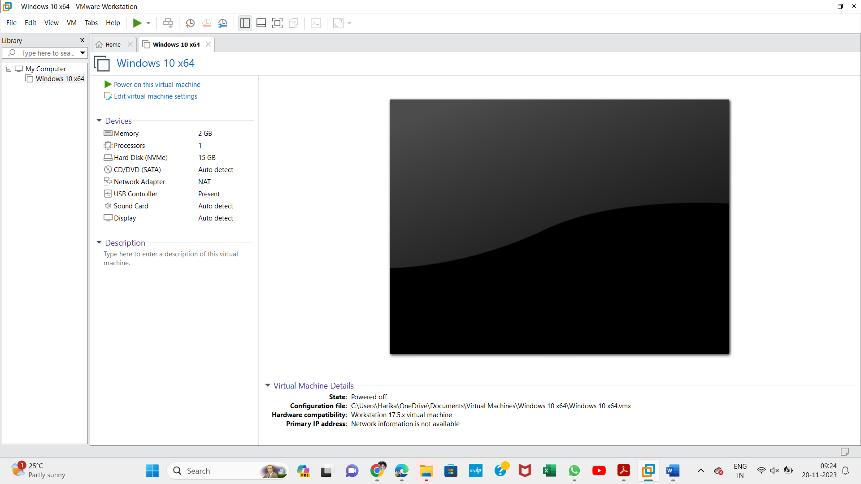

Output:

Result

Thus, a virtual machine was created and configured using VMware
Workstation, a Type
-
2

hypervisor, with 1 CPU, 2 GB RAM, and a 15 GB virtual hard disk.

